Station 1
The Independence Movement in Georgia
On April 19, 1775, Massachusetts “minute men” and British troops battled at Lexington and Concord. It was, as later described, “the shot heard ’round the world.”News of the battles spread quickly throughout the colonies. Colonial assemblies voted to raise militias to defend themselves against the British. The war for American independence had begun. In Savannah, patriots greeted the news with great excitement. They openly defied Georgia’s royal government. They raided the colony’s gunpowder store house and disrupted Governor Wright’s celebration of the king’s birthday. Amid much confusion, the royal government began to fall apart.

Georgia Chooses Sides
Georgia was much younger than the other American colonies and didn’t have a long history of self-government. Also, along the coast a number of Georgians had become wealthy from trade with Great Britain. Under the royal governor, Sir James Wright, the colony had grown and prospered. Thus, when northern colonies began pushing for freedom from Britain, Georgia was not quick to join in.
Loyalty to Great Britain was strongest in coastal Georgia. Far in land, backcountry Georgians were far more likely to want independence. However, even in coastal Georgia, support of the mother country began to weaken. Georgians soon began to take sides. As in the other colonies, anti-British Georgians were known as Whigs and later as “patriots.” Supporters of Britain were called Tories or “loyalists.” Colonists that remained uncommitted were known as “fencesitters.”
Differences with Britain sometimes caused a split within families. Typically, first-generation Georgians were loyalists, tied to England by tradition, friends and relatives, and strong memories of their mother country. Noble Jones and James Habersham, two of the earliest Georgia colonists, never wavered in their support of King George III and royal government. On the other hand, their Georgia-born children often joined in the fight for liberty. Noble Wimberly Jones and the three Habersham boys—James Jr., John, and Joseph—became political and military leaders in the Whig cause.
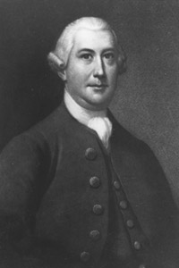
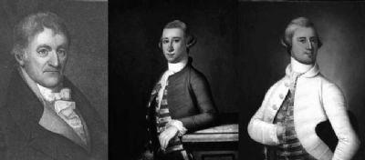
Station 2
Royal Government Comes to an End
In July 1775, a “Provincial Congress” of delegates from Georgia’s parishes met in Savannah. The delegates voted to join the other colonies in a complete boycott of trade with Great Britain. The Whigs also set up a “Council of Safety” to enforce the boycott and to work with other colonies.
For a while, Georgia had two governments. Britain’s royal government, headed by Sir James Wright, and the Whigs’ provisional (temporary) government. The days of royal government, however, were numbered as anti-British sentiment built in Georgia. Gradually, the Whigs took over Georgia’s militia, removing Tory officers. They approved new taxes to finance Georgia’s defense against British attack. They also took control of the courts and other government activities—such as handling Indian relations. Governor Wright was powerless. He watched as his royal authority crumbled.
In January 1776, Whig forces arrested Governor Wright, who managed to escape to the safety of a waiting British warship. This meant the end of the royal government, at least for the time being. Many Georgians still remained loyal to King George. Political control, however, now rested with Whig factions.

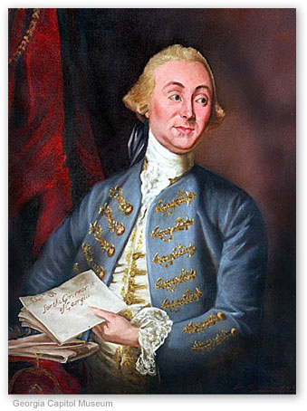

Station 3
The Continental Congress Acts
In May 1775, the Second Continental Congress convened in Philadelphia. This Congress became the acting government for the American colonies. This time Georgia sent five delegates to Philadelphia. These colonial representatives had to decide what to do. Would it be war or peace? The delegates decided to prepare for both.
On June 15, 1775, the Congress named George Washington as commander in chief of the Continental Army. Two days later, American forces repelled three British assaults at the Battle of Bunker Hill (actually fought on Breed’s Hill) before running out of gunpowder and being forced to retreat.
In July, delegates sent King George III a petition (a formal written request) stating their loyalty to him but asking him to stop Britain’s hostile actions against the colonies. In London, King George refused to accept their petition. Instead, he declared the colonists in a state of rebellion. Parliament banned all trade with America.
American colonists remained divided, but the independence movement gained strength throughout the spring of 1776. Finally, in May, delegates to the Second Continental Congress voted to instruct each of the colonies to prepare for the end of British rule. Delegates debated how and when to announce a formal break from Great Britain.
On July 4, 1776, the Second Continental Congress took action, adopting the Declaration of Independence. All the delegates signed the document, including Georgia’s delegation—Button Gwinnett, Lyman Hall, and George Walton.
This revolutionary document, written mainly by Thomas Jefferson of Virginia, included the following ideas:
1. All men are created equal.
2. Everyone is born with certain rights that government cannot take away—namely life, liberty, and the pursuit of happiness.
3. Government gets its power from the people.
4. The people can do away with a government they no longer approve of.
The declaration ended with the bold proclamation that “these United Colonies are . . . Free and Independent States.’’ All political connections between the new states and Great Britain were dissolved.
On paper at least, the 13 American colonies were now independent “states” united in their desire for freedom from Great Britain. At that time, state was another word for nation. Both terms referred to an independent country with its own government. Only later did “state” come to have an additional meaning in America as a level of government below that of the nation.
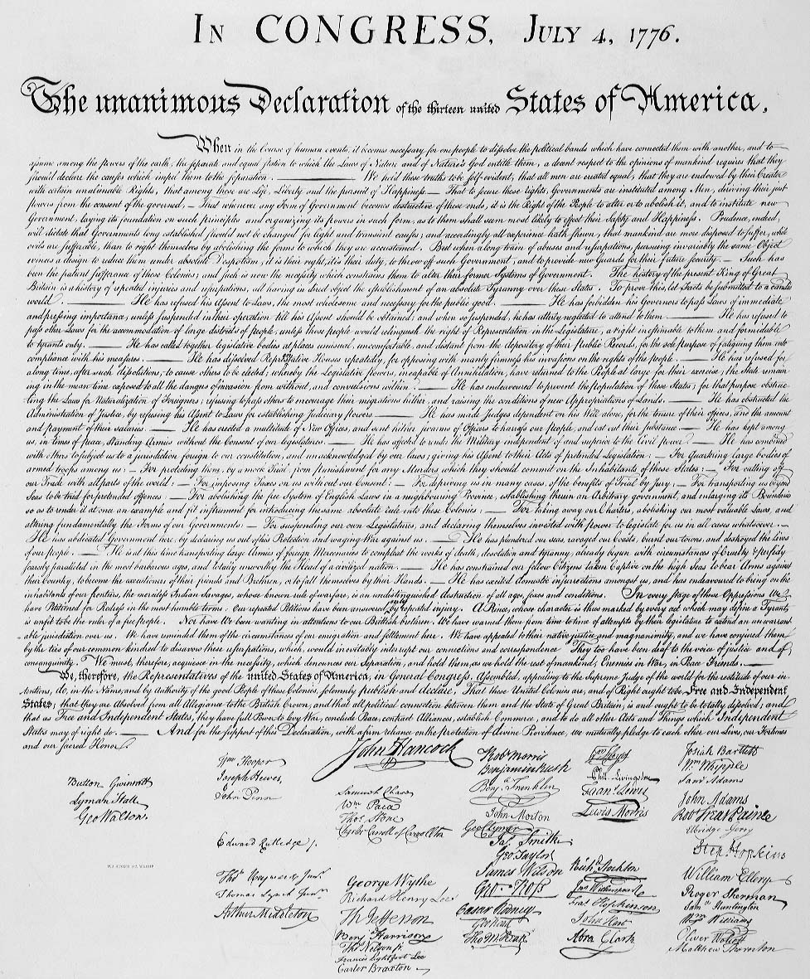

Station 4
Reaction in Georgia to the Declaration of Independence
Although it was signed on July 4, 1776, news of the Declaration of Independence did not reach Georgia for a month. In early August, the declaration was read publicly in Savannah. Patriots fired cannons and staged a mock funeral for King George III.
Other Georgians, however, did not share in the celebration. Some 1,500 Tories decided to leave Georgia. Some left for East and West Florida or went to British colonies in the Caribbean; some returned to Britain. Many loyalists, however, stayed to protect their property, but kept quiet about their feelings toward Britain.

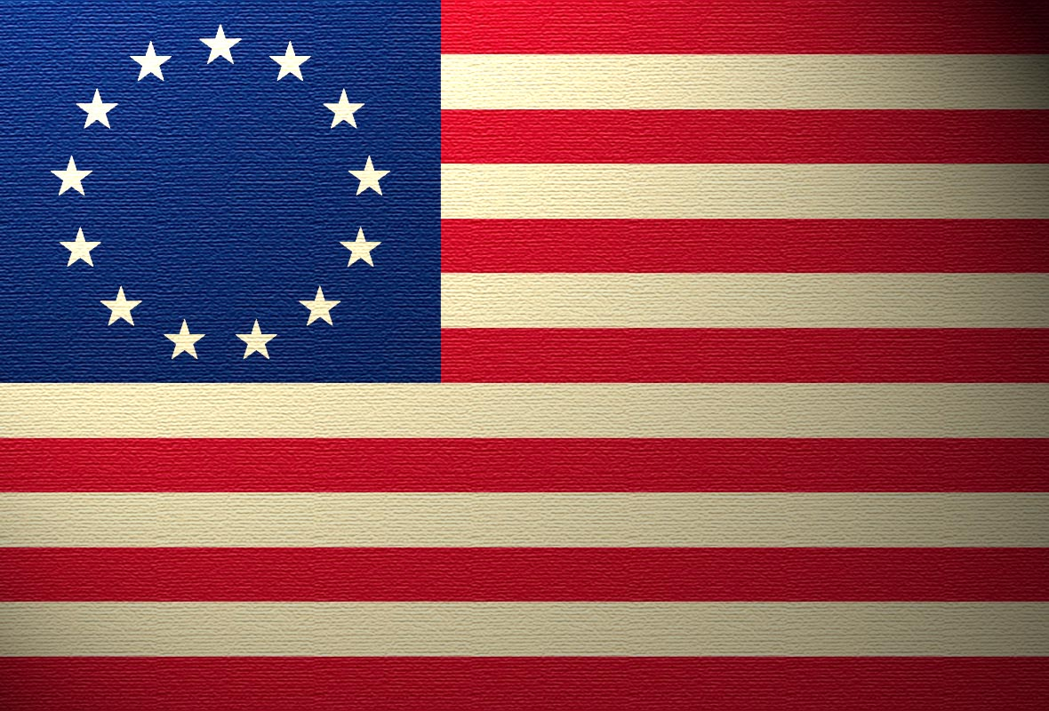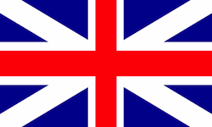

Station 5
Problems of the New State Government
In May 1777, Georgia’s first constitution went into effect. The House of Assembly named John Adam Treutlen the first governor of the state. Georgia’s political leaders, however, faced great difficulties. Thousands of people were still loyal to King George III and wanted to see the new government fail. Even more of a problem was a power struggle among different Whig groups.
Bitter feelings between members of a radical backcountry party and a conservative city party led to the death of one of Georgia’s signers of the Declaration of Independence. In the 1700s, it was common for a gentleman to defend his honor to the death with sword or pistol. When conservative Lachlan McIntosh publicly called radical Button Gwinnett “a scoundrel and lying rascal,” Gwinnett challenged him to a duel. On May 16, 1777, the rivals exchanged pistol shots outside Savannah. Both were wounded and Gwinnett died three days later.
Of course, the biggest difficulty facing the new government was war with Great Britain.

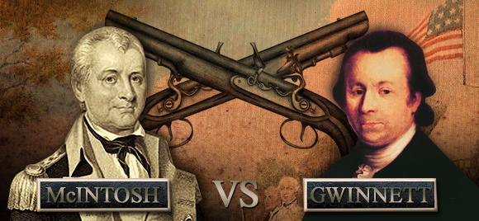
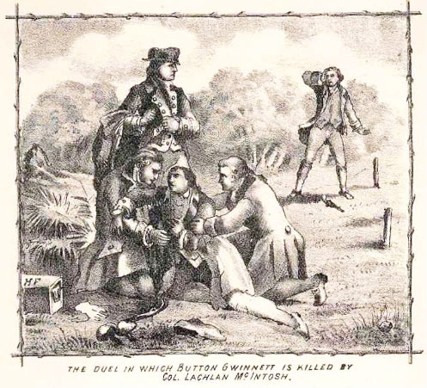

Station 6
War Comes to Georgia
With British troops occupied in the North, Georgia was spared from battles during the early years of war. Still, there was no real peace at home. Only about one-third of the Georgians were Whigs. Another third were Tories, and the rest remained neutral, waiting to see what would happen. From 1776 to 1778, with the Whigs in control, some of the Tories were driven out of Georgia, their property taken over by the state. In addition to this fighting between Georgians, fights erupted between Georgia patriots and loyalists in East Florida. On three occasions, Georgia forces participated in failed attempts to capture the British garrison at St. Augustine.
Counting on the help of loyalists and Indian allies, Britain in 1778 decided to try to regain control of the Carolinas and Georgia. In December, a British army from New York reached Savannah. A force of 700 patriots faced more than 2,000 British soldiers. The battle was over quickly. More than 100 of the American defenders were dead, and 450 captured. Georgia’s Whig government barely escaped. British troops moved on to Sunbury, Augusta, and Ebenezer. By the end of January 1779, every important town in Georgia was in the hands of the British.
Meanwhile, Sir James Wright, who had fled in 1776, returned to Savannah to reestablish royal authority. Many loyalists came out of hiding to openly support British authority.
Some wealthy coastal planters did take an oath of allegiance to the king, but the back country farmers held out for independence. Far inland from the coast, state leaders tried to carry on the fight, meeting wherever they could. The British and the Tories, however, kept them on the run.
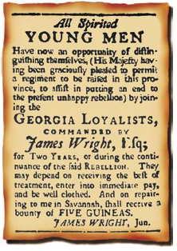
The Revolutionary War in Georgia
-This 1779 recruitment poster advertises to raise an army of Georgia loyalists.
- Because Georgia was the southernmost colony, there were fewer battles here than in the more northern colonies.

Station 7
Constitutional Foundations
A constitution is the fundamental plan of operation for a government. As the highest level of law, it spells out what government can and cannot do. It sets up the different branches of government, identifies major offices in each branch, and says how each office is to be filled. A constitution may also spell out important rights and liberties of the people.

Georgia’s First Constitution
In April 1776, Georgia’s Provincial Congress adopted a set of “Rules and Regulations” as a temporary constitution. In clear language, its preamble (introduction) proclaimed the concept of popular sovereignty—that government rests on the will of the people: This Congress, therefore, as the representatives of the people, with whom all power originates, and for whose benefit all government is intended . . . do declare, order, and direct that the following rules and regulations be adopted in this
Province. . . .
As a state, Georgia needed a more permanent form of government than the “Rules and Regulations.” An election was called to select delegates to write a new constitution. By February 1777, the convention had completed its work. The preamble to the new constitution recognized the important principle of popular sovereignty. The very first article of the new constitution, however, introduced a new principle—that of separation of powers: The legislative, executive, and judiciary departments shall be separate and distinct, so that neither exercise the powers properly belonging to the other.
Although Georgia’s 1777 constitution appeared to create three independent branches of government, in reality the legislative branch was supreme. The constitution set up a unicameral (one-house) legislature. Unlike Georgia’s state government today, there was not a second house acting as a safeguard against hastily passed laws. The legislature, called the House of Assembly, was given broad authority to enact laws. It also had power to appoint officials in the executive and judicial branches.
Because of their experience with royal governors under British rule, framers of Georgia’s 1777 constitution severely weakened executive power in the new state government. For example, legislators elected the governor, who only had a one-year term and could not succeed himself in office. The governor could not veto legislation. In fact, just the opposite was true. The legislature elected 12 of its own members to serve as an executive council, with veto power over the governor. The power to grant pardons, traditionally an executive function, was placed in the hands of the legislature. This left the governor as chief executive in name only.
The constitution set up eight counties to replace the colonial parishes. Each county would have its own officials, courthouse, schools, and militia. To settle disputes, each county had a court, called the superior court. The constitution stated how cases were to be tried.
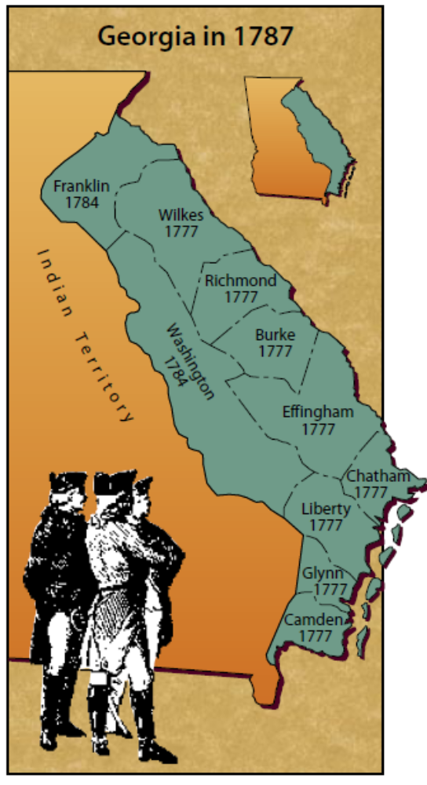
Station 8
State Government
In 1789, Georgia adopted a new state constitution, one more in line with the new national constitution. Like the national Congress, the Georgia legislature would now be bicameral (or two-house), with a Senate and a House of Representatives. As in the 1777 constitution, Georgia’s state government would have three branches. But unlike the federal government, the
branches were not balanced. Most real power rested with the legislature (known as the General Assembly). Legislators controlled raising and spending money; chose the governor, the judges, and other state officials; and even granted divorces.
The highest courts in the state were the superior courts. Superior court judges traveled a regular “circuit” from city to city by horse back or stagecoach. They handled the most serious cases in several counties. Each county had an inferior court for less serious cases, and each community had a justice of the peace court to handle minor matters.
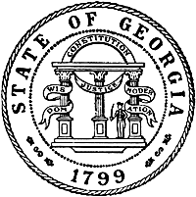

Station 9
Battle of Kettle Creek
Early in 1779, at Kettle Creek in Wilkes County, Lt. Col. Elijah Clarke led a force of Georgia patriots in an attack against British loyalists. Aided by South Carolinians, the patriots scattered the Tories, killing their British commander.
Although the Battle of Kettle Creek didn’t involve large armies, it was important to the patriot cause. The patriots gained badly needed arms, ammunition, and horses. Also, their victory won over many Georgians who had been lukewarm in their support of the war. Never again were the Tories able to gather a large force in the backcountry.
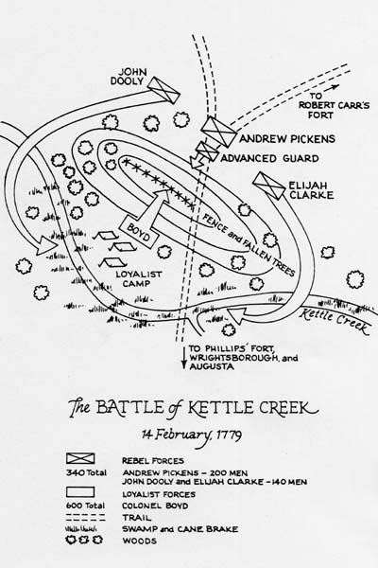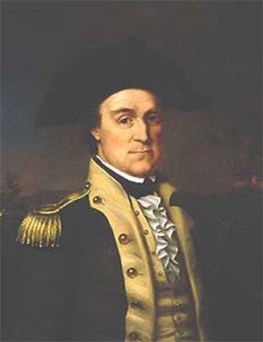

Station 10
Siege of Savannah
During the fall of 1779, patriots—aided by France, which had joined the American side—tried desperately to retake Savannah. An American army and a French fleet laid siege to the city for three weeks. After a fierce bombardment, the Americans attempted to take the city by storm. In a daring cavalry charge, Count Casimir Pulaski, a Polish nobleman who had come to America to help the patriots, was killed. The attack failed.
In the end, the British were able to hold Savannah and lost only 150 men. The Americans and their allies had 1,000 men killed or wounded and gained nothing.
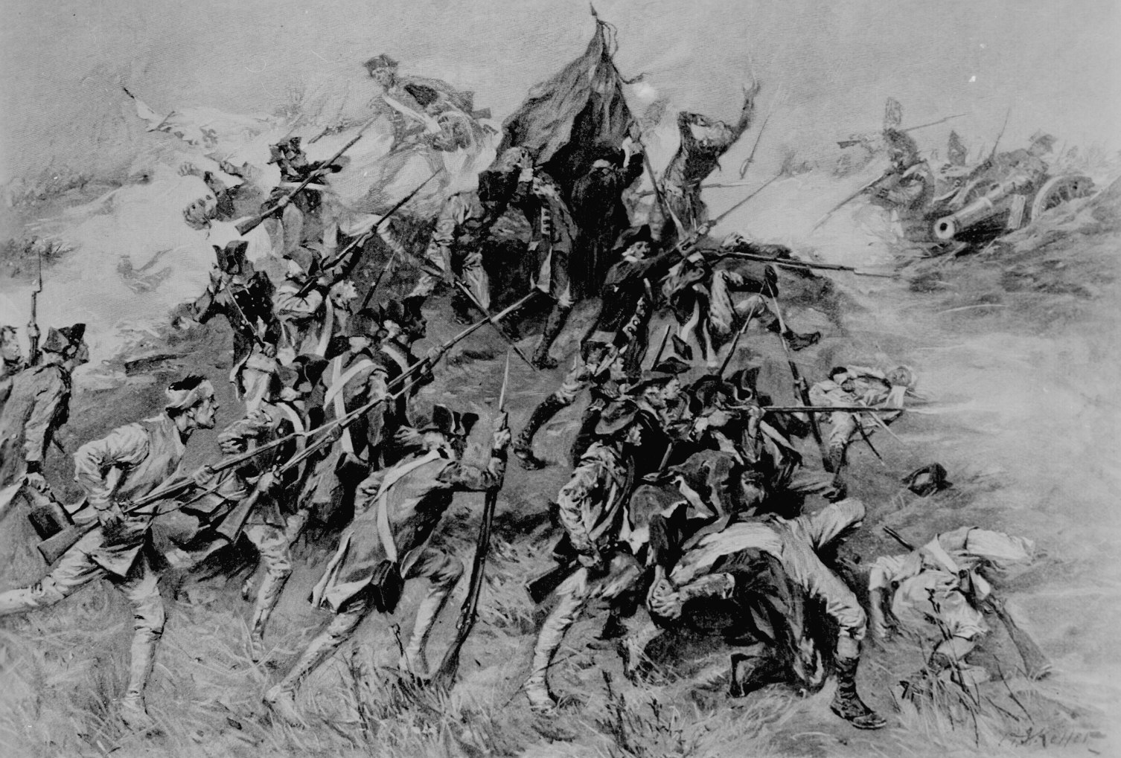

Station 11
The End of the War
During 1780, the British controlled most of Georgia. It was the only one of the 13 former colonies in which the king’s government was restored. However, the Whigs and the Tories continued their bitter fighting in the backcountry. Families were driven from their lands, their homes burned, their livestock killed, and their crops destroyed.
In 1781, the Whigs recaptured Augusta. Overall, though, the Patriot cause looked bleak, despite the entry of Spain and France as American allies. British general Charles Cornwallis had moved his army to Yorktown, Virginia, in an attempt to take control of the South. Aided by a French fleet, the patriots were able to mount a siege. As General Washington prepared to attack the British, Cornwallis surrendered his army. For all practical purposes, this marked the end of the American Revolution. However, it took a while for the British to withdraw their troops. In the spring of 1782, the Tories and the British troops gave up Georgia. As the American troops marched joyfully into Savannah, more than 2,000 Tories and their slaves left the state. All of Georgia was once again under control of its own government.
The American Revolution ended with the signing of the Treaty of Paris in 1783. Georgia, along with the other former colonies, was now a free and independent state. However, all its troubles were not over.
During the revolution, Spain had joined the struggle and seized West Florida from the British. As part of the peace treaty, Britain had to return East and West Florida to Spain. But the United States disagreed with Spain over the northern boundary of West Florida. For the next 12 years, ownership of a sizeable area of Georgia’s western land was in dispute.
Unfriendly Indians, some of whom had taken the British side in the war, posed a threat along Georgia’s frontier. Georgia now faced some of the same problems as before the war. This time, however, the problems would be handled by a state, not a colony
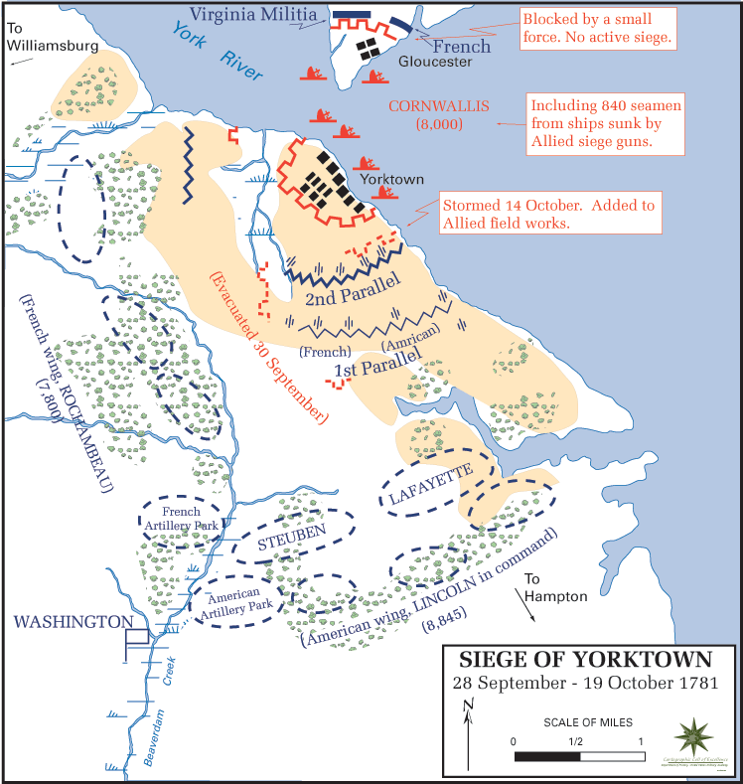

Station 12
Slaves Join the Fight
Prior to the American Revolution, almost half of Georgia’s 33,000 inhabitants were black slaves. During the war some slaves helped the patriots. However, far more earned their freedom by siding with the British. Why? Early in 1776, British commanders began offering freedom to any slave who would join their fight against the American colonists. Eventually, this offer was extended to include the family and relatives of each black recruit. For black slaves, it was not a matter of disloyalty. Rather, to them, freedom from slavery was more important than freedom from Great Britain.
In some cases, slaves helped the British not as soldiers but as spies or guides. In the December 1778 battle for Savannah, Quamino Dolly led a British invasion force through little-known swamp paths to bypass a patriot force. Because of his help, the British were able to attack the Americans from the rear and win a total victory, capturing Savannah.
After Savannah’s capture, British-occupied areas of coastal Georgia became a haven for escaping slaves. By war’s end, as many as 10,000 Georgia slaves had won freedom by siding with the British. After Americans won the revolution, some of the blacks who had fled to Georgia’s coast were reenslaved. However, many fled to Indian territories in extreme south Georgia and Florida. Some were evacuated to Canada or other British colonies in the Caribbean.


